Shay Walker April 8, 2019

Software Engineering Professor Worth

CairnConnect User’s Manual

Welcome to CairnConnect! Here is a complete guide on how to get started with this program. This program is designed to help Cairn University Alumni maintain relationships and contact with one another as well as with Cairn University.

First, you will go to <http://csinfo.cairn.edu/~sw344/index.php>. You will find yourself at the CairnConnect Welcome page. You will have the options to log in or sign-up through the link that is beneath the submit button.

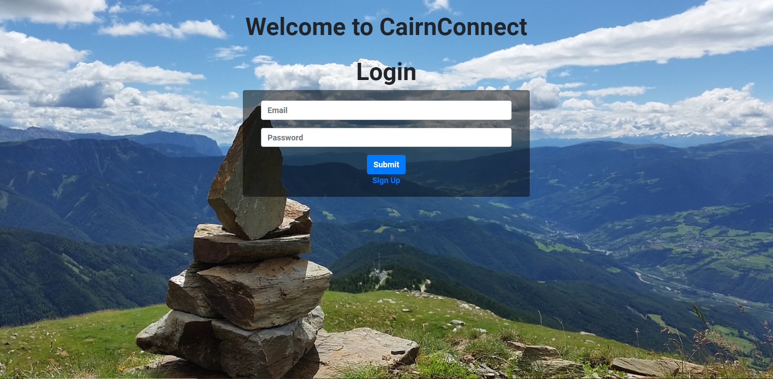

If you have not already registered an account then you will need to click on the sign-up link and fill out the form in order to establish a CairnConnect account. See the form below.

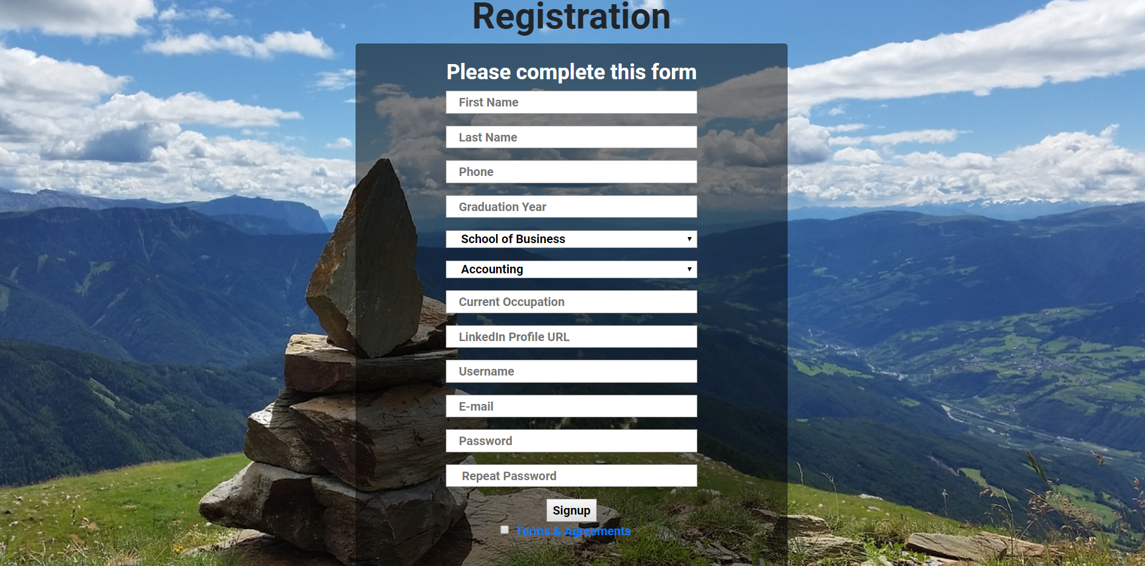

Otherwise, if you have already completed the sign-up process then your account has been established and you will use your email and password made when you created your account. You will log in on the Welcome page as seen in figure 1.

After you have logged in or registered an account you will be directed to the CairnConnect Home page. Here you will find Alumni News listed on the page. You will also have access to multiple links Located on the Navbar at the top of the page.

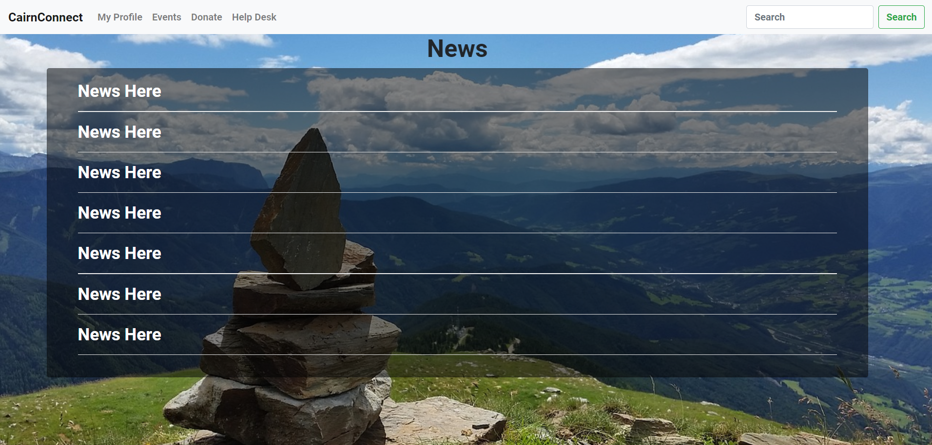

In the Navbar at the top of the page, the CairnConnect link will bring you back to the News Page. The My Profile link will bring you to your profile. This page will list the information provided when you created your account.

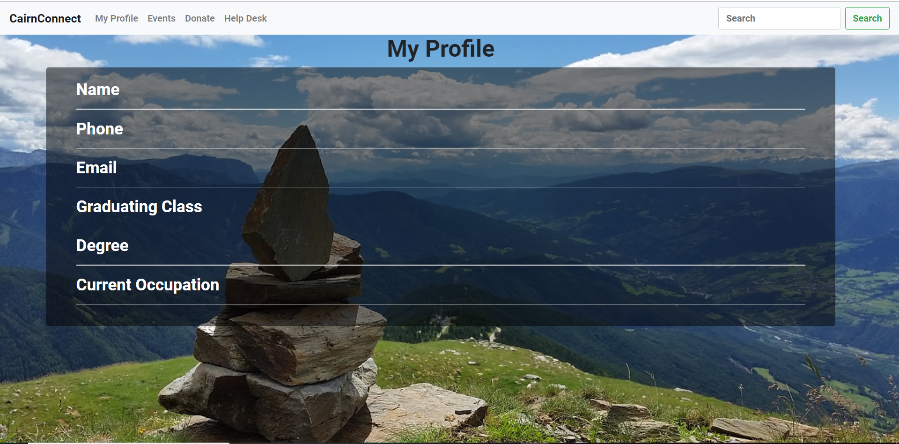

At the top of the page in the Navbar, there is an edit button that you can click on to edit any of the information on your profile. Once done editing you click the save button and you will be redirected to the My Profile page to view the changes you have just made. You can then proceed around the rest of the application from the Navbar at the top of the page.

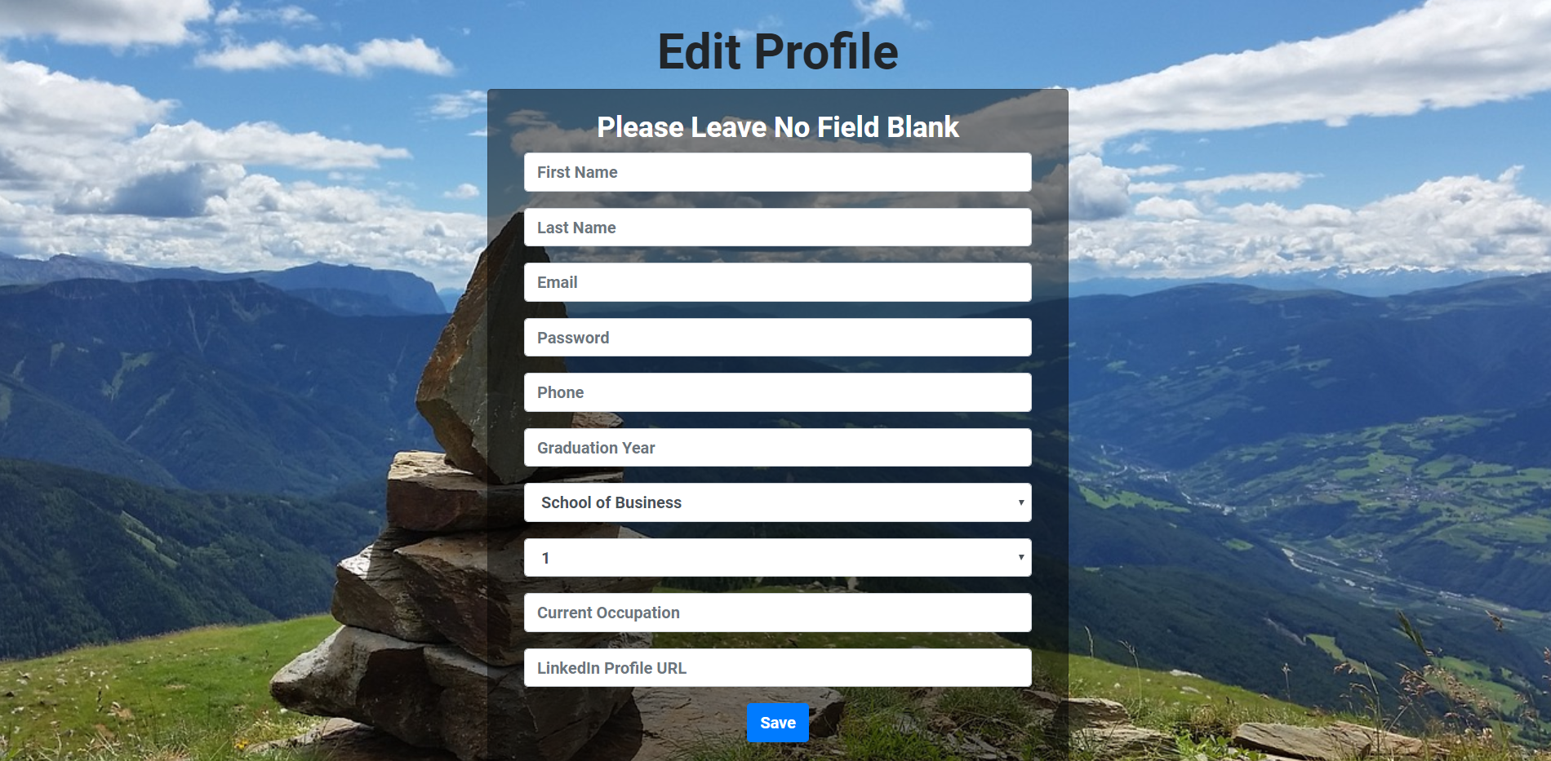

If you click on the Events link in the Navbar it will bring you to the Cairn University Events Calendar website for you to view the events happening at the university.

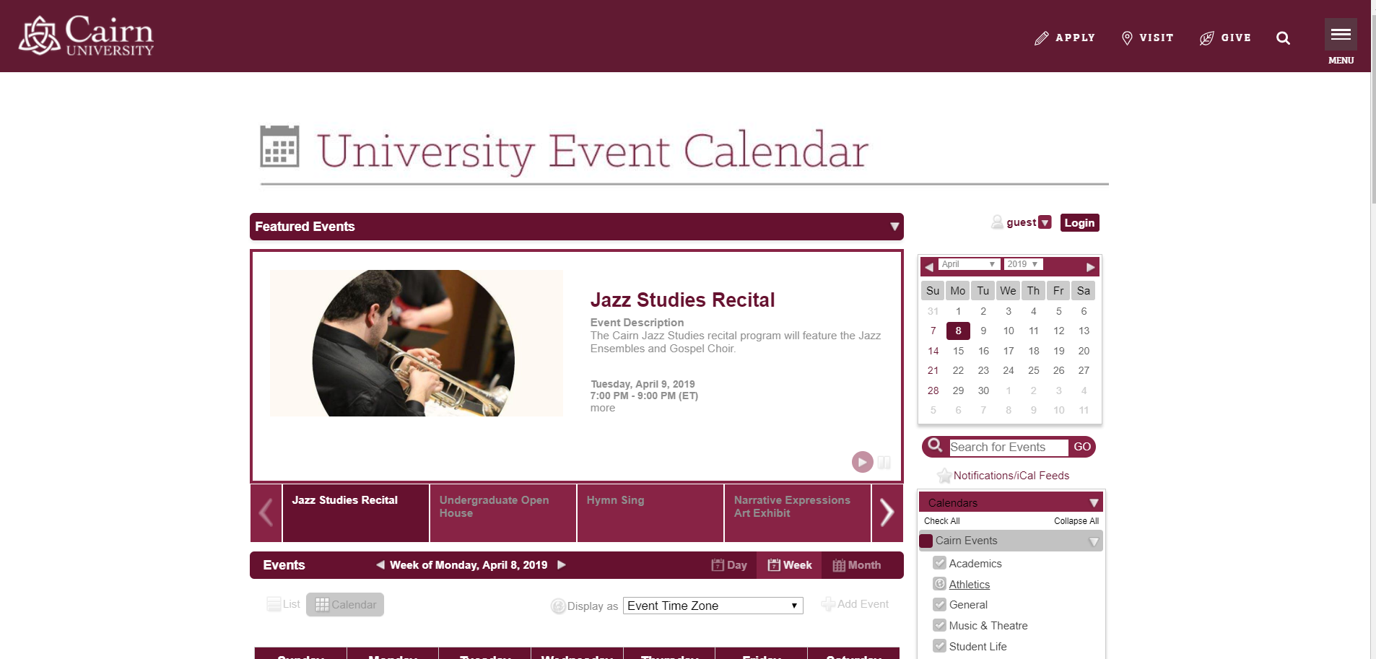

If you click on the Donate link from the Navbar at the top of the page you will be directed to the Ways to Give website.

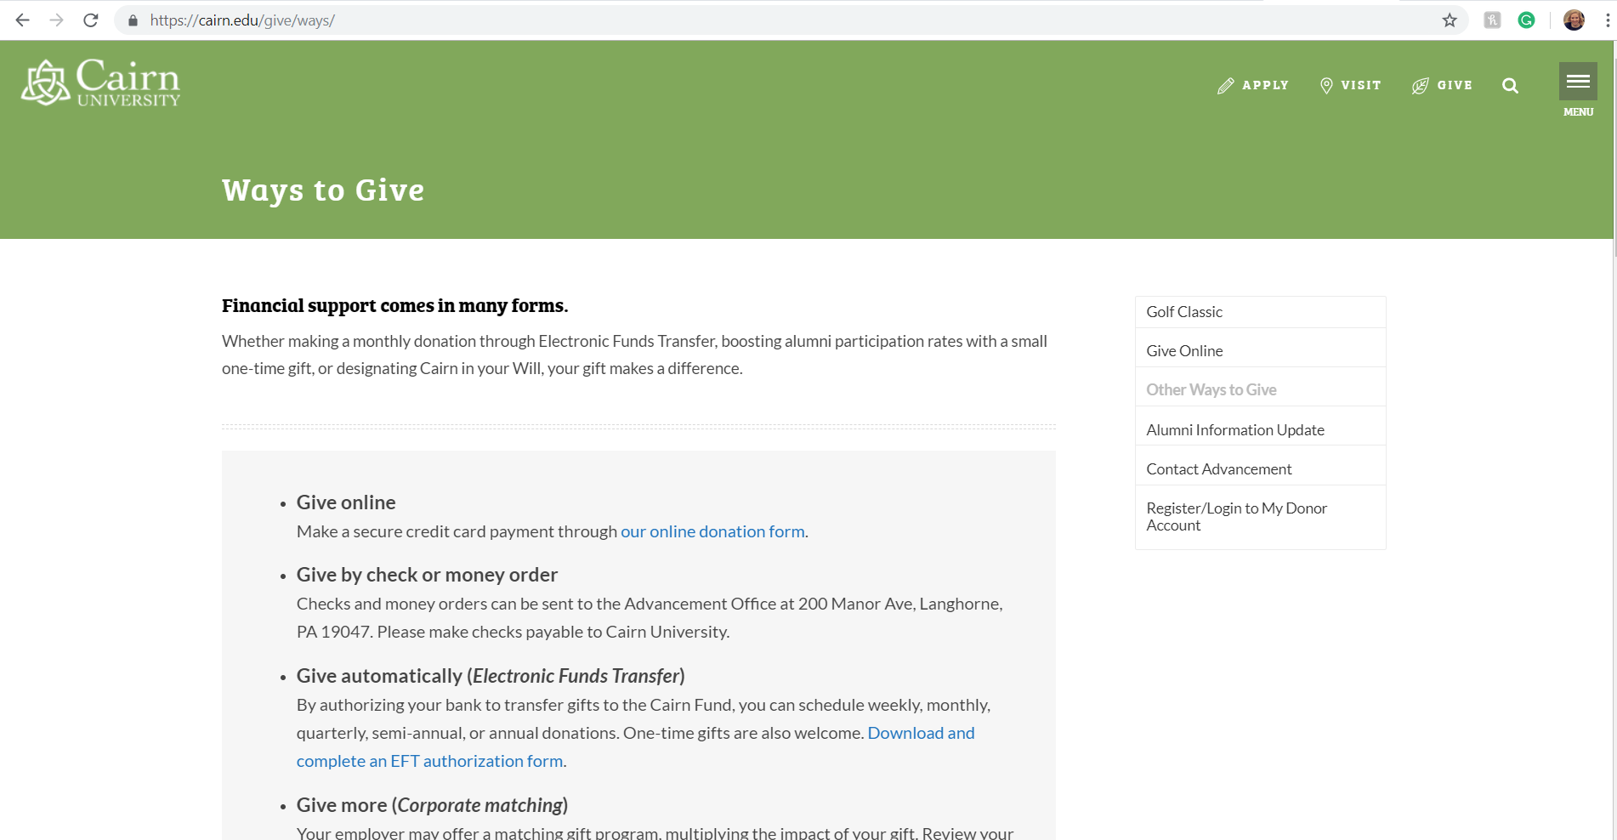

If there are any issues or if you have any questions please click on the Help Desk link in the Navbar at the top of the CairnConnect page. You will be directed to a form to complete and a staff member will email you as soon as possible to address your problem, issue, or question.

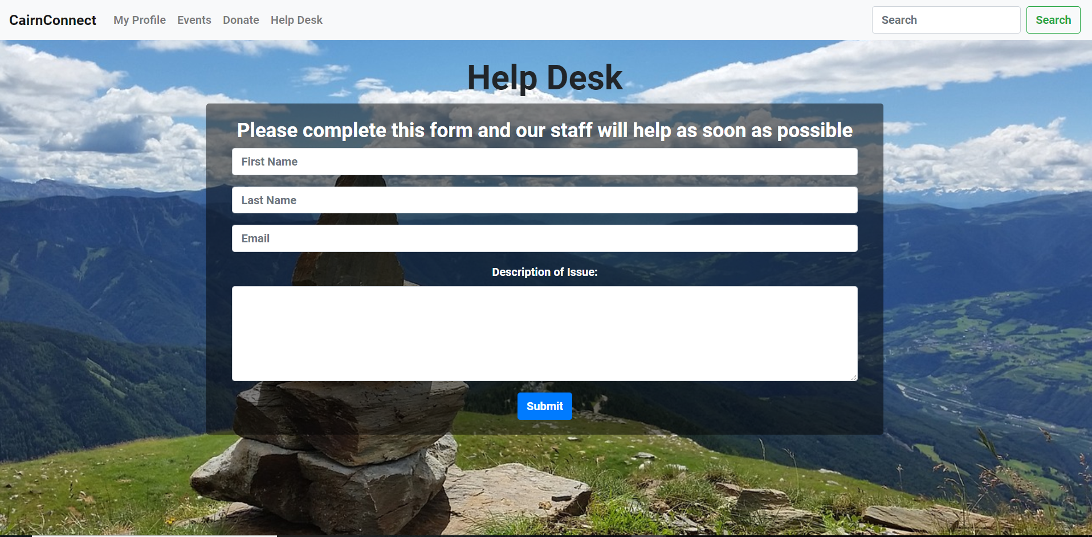

The search function is also located in the Navbar. The search bar can be used to search for other alumni and their profiles. You can type a name into the search bar and click the search buttons and you will be directed to the search results page with the names of other alumni profiles. You can do a more specified search is you desire. Each result displayed will include their name, class year, and major. You may select one by clicking on it to view their profile.

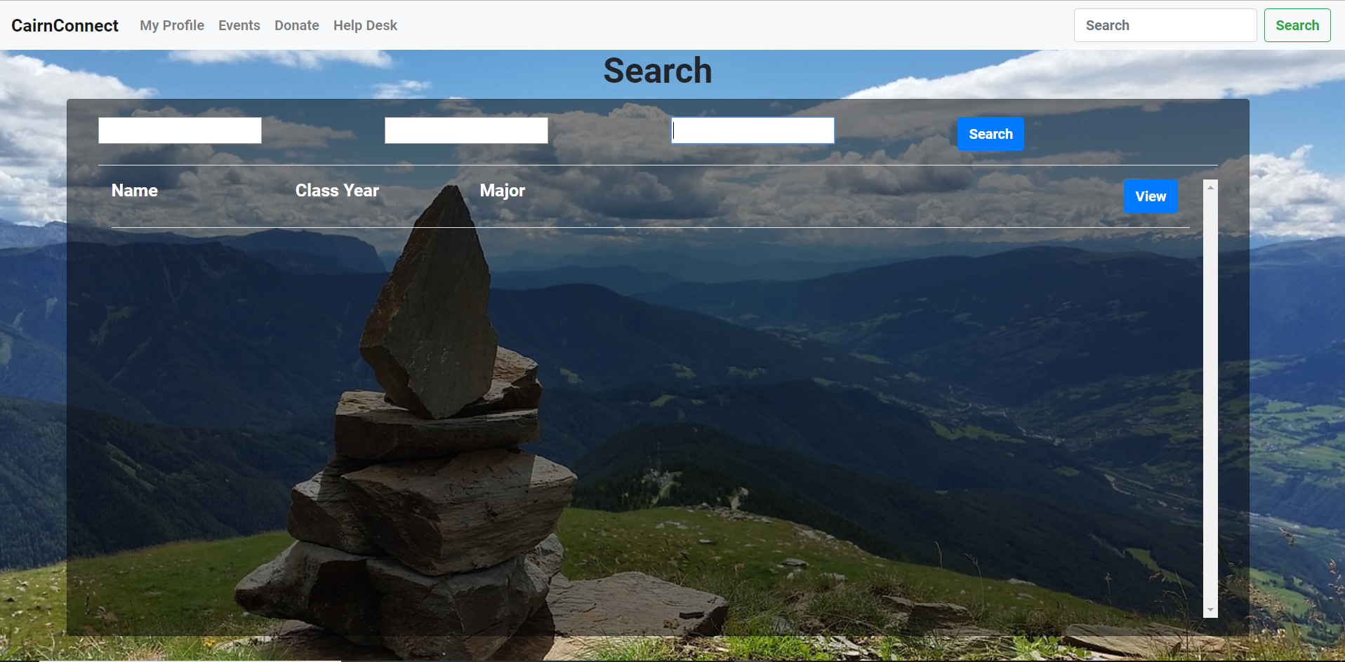

Finally, to log out please click on the log out button to the left of the search box in the Navbar. You will be logged out and brought back to the Welcome page.

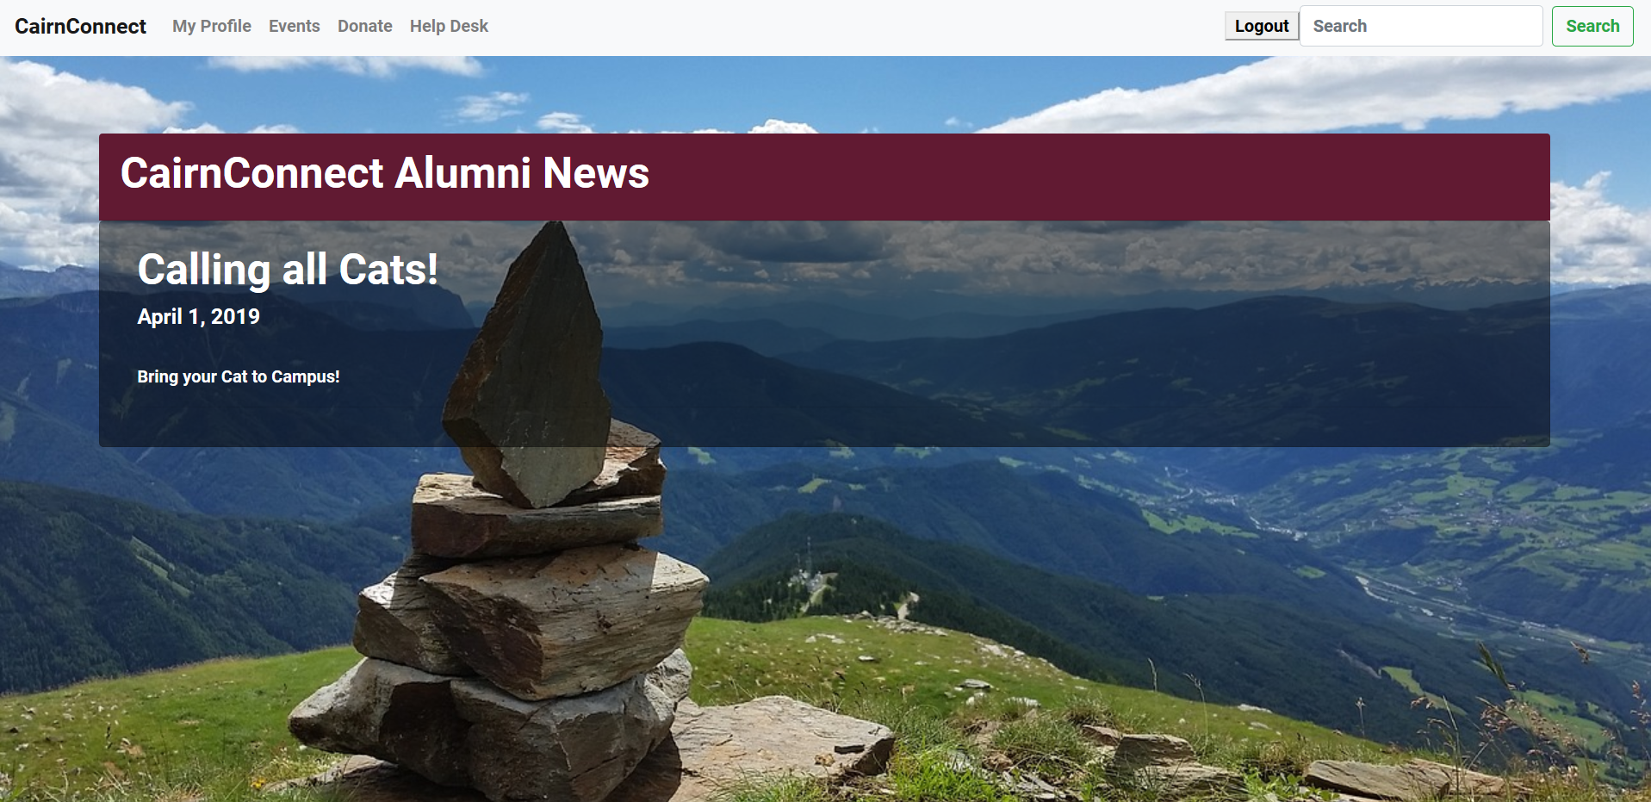

ADMINISTRATIVE GUIDE:

For administration, an administrator account will be set up in order to maintain the database as well as view the web application.

As Administrator, you will need to navigate the sw344 database and its tables to edit and change the News on the News Page as well as answer Help Desk Requests. Please view the User’s Manual above for instructions on how to navigate the site. For Database instruction please see the following instructions.

NEWS:

After logging into the database with the credentials provided, you will navigate to the sw344 database. Here you will find a table labeled News. This is the table you will edit to have new event display on the News page and to remove the old events.

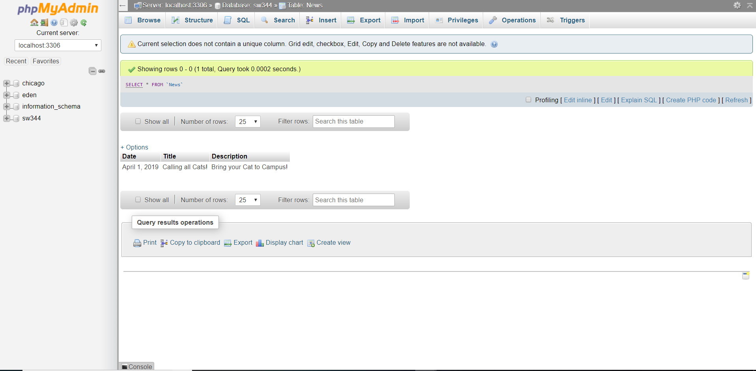

Select the sw344 database to see a drop-down menu of tables on the left of the screen. Then select the News table. Next click on the insert tab at the top of the page. This will bring you to the following page.

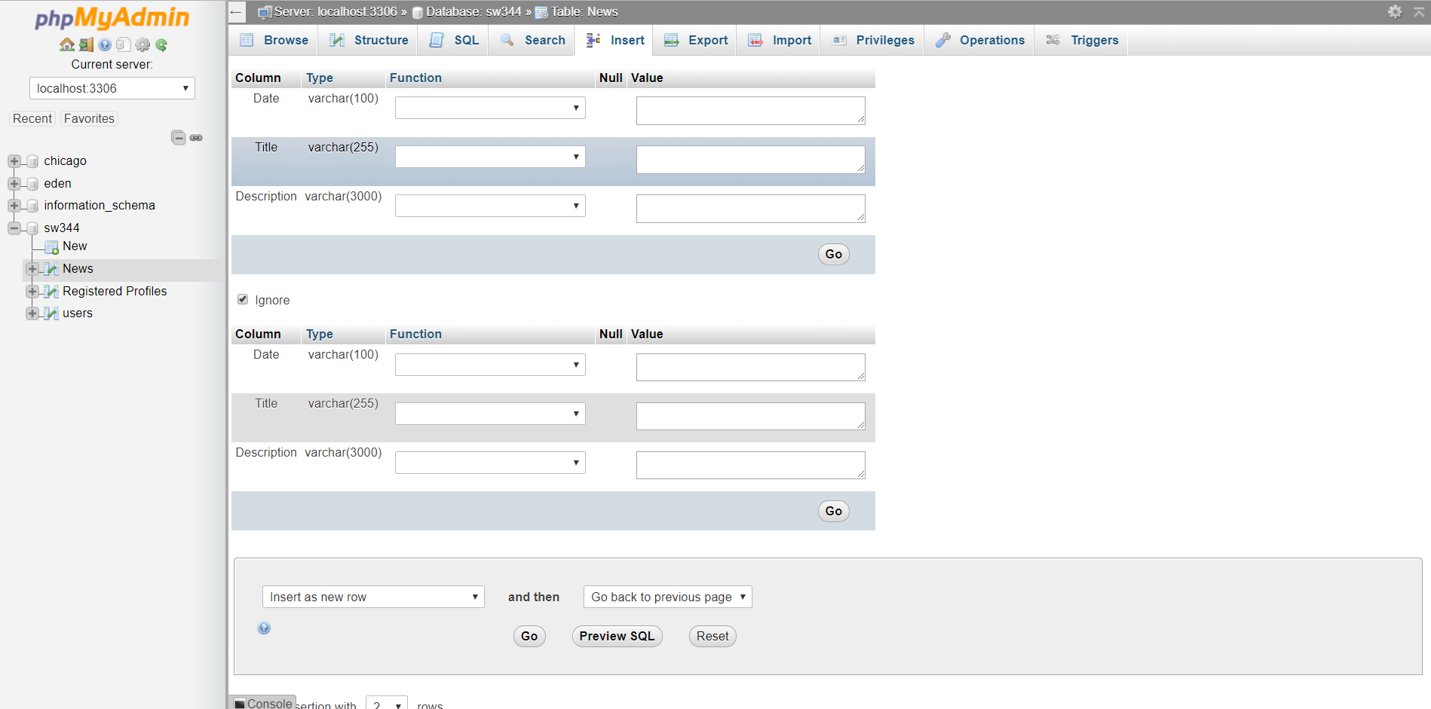

In the column where the label is Value insert into the input boxes the appropriate date, title, and description of the News Event. You can insert one or two events at a time. Then click the Go button at the bottom of the page. This will insert these events into the database.

To delete items from the database, click the Browse Tab at the top of the page. Then click the delete key on the entry you wish to remove from the database.

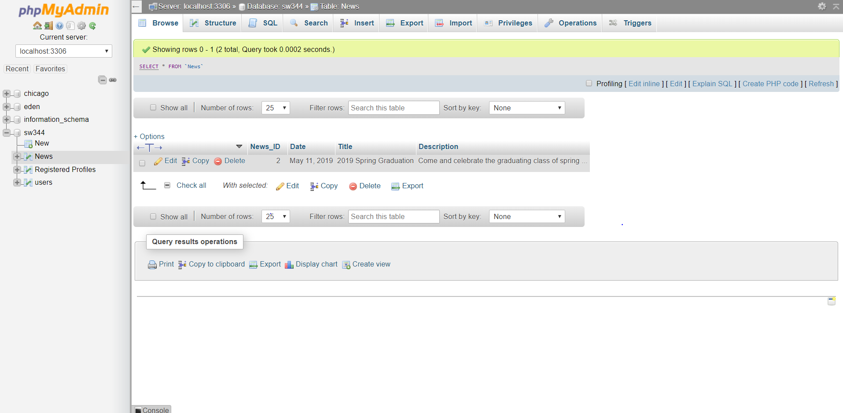

HELP DESK:

Within the database, there is a table named Help_Desk. Here is where all of the help desk requests are stored. The submitter's name, email, and issue will be in the database entries. Once you have emailed them and addressed their issue then the entry can be deleted from the database (See instructions to delete above). Please use your administrative email to answer the requests.